7032SCN — AI Systems and Human Factors
Integrated AI Systems Portfolio
Medical Diagnosis Support Agent — Healthcare Domain

Student Name: Divya S Yellampalli
Student ID: 15735056
Module Code: 7032SCN
Assignment: Integrated AI Systems Portfolio
Module Leader: Manizheh Montazerian

Portfolio Overview
This portfolio presents an integrated Medical Diagnosis Support Agent situated in the healthcare domain. Healthcare is a high-stakes, information-rich environment in which clinicians must make rapid decisions under uncertainty, manage limited resources, and document large volumes of patient information. These pressures make the domain a strong candidate for decision-support AI, while also raising serious questions of fairness, safety, privacy and accountability. The portfolio therefore pairs technical implementation with critical human-factors analysis throughout, treating the AI as an assistant to clinical staff rather than a replacement for them.
Five connected activities build a single coherent system. Activity 2 applies Bayesian updating to estimate disease probability from imperfect test evidence, providing a principled treatment of diagnostic uncertainty. Activity 3 uses Q-learning, a model-free reinforcement-learning method, to recommend sequential treatment actions as a patient's condition evolves between critical, stable and recovered states. Activity 4 formulates hospital appointment scheduling as a human-centred optimisation problem and solves it with Particle Swarm Optimisation to reduce patient waiting time. Activity 5 implements a generative transformer model (Google FLAN-T5) that drafts clinical summaries from structured patient records, reducing documentation workload. Activity 6 conducts a structured governance audit of the combined system, examining stakeholders, ethics, privacy, security, safety and deployment readiness.
The activities connect through a shared agent, a shared patient-centred dataset, and a consistent stakeholder set of patients, clinicians, hospital administrators and regulators. Across all five, the same human-factors thread recurs: every technical gain in accuracy, efficiency or automation is weighed against transparency, bias, patient safety and the requirement for meaningful human oversight. The portfolio's central argument is that these techniques can materially improve healthcare efficiency, but only when deployed as transparent, auditable and human-supervised decision-support tools.

Activity-to-Learning-Outcome Mapping
Activity | LOs | How it is evidenced
Activity 2 — Bayesian Updating | LO1, LO3 | Decision-making under uncertainty using priors, likelihoods, posteriors and sensitivity analysis.
Activity 3 — Q-Learning | LO1, LO3 | Sequential decision-making with reinforcement learning; baseline comparison and policy evaluation.
Activity 4 — Particle Swarm Optimisation | LO1, LO2 | Meta-heuristic optimisation of a human-centred scheduling problem with constraints and baseline.
Activity 5 — Generative AI (FLAN-T5) | LO4, LO5 | Transformer implementation for clinical-summary generation; real-world application and stakeholder impact.
Activity 6 — Governance Audit | LO1, LO4, LO5, LO6 | Critical audit of ethics, privacy, security, safety and deployment readiness across Activities 3–5.

Across the five activities all six module learning outcomes (LO1–LO6) are addressed.

Activity 2 — Decision-Making Under Uncertainty and Bayesian Updating

2.1 Problem Framing
Medical diagnosis is intrinsically uncertain: symptoms overlap across diseases, and diagnostic tests are imperfect, producing both false positives and false negatives. A clinician rarely observes a disease directly; instead they observe evidence and must reason about how strongly that evidence supports a diagnosis. This activity frames diagnosis as probabilistic inference, where the agent estimates the probability that a patient has a disease given a positive test result. The problem matters because over-diagnosis leads to unnecessary, sometimes harmful, treatment, whereas under-diagnosis delays care. The stakeholders are patients, whose safety depends on calibrated decisions, and clinicians, who need a transparent estimate they can interpret and challenge (Russell and Norvig, 2021; Pearl, 1988).

2.2 Decision Model
The agent uses Bayesian updating combined with expected-utility reasoning. Bayes' theorem combines a prior probability of disease with the test's sensitivity (true-positive rate) and false-positive rate to produce a posterior probability: P(Disease | Positive) = [P(Positive | Disease) × P(Disease)] / P(Positive), where the denominator P(Positive) = sensitivity × prior + false-positive-rate × (1 − prior). Each new piece of evidence updates the posterior, so the model naturally supports sequential accumulation of evidence. The posterior is then mapped to a risk band and an action recommendation, an explicit expected-utility step that converts a probability into a clinically meaningful decision.

2.3 Python Implementation
The model was implemented in Python (full code in Appendix A). A single worked example uses a prior of 0.05, sensitivity 0.90 and false-positive rate 0.07, giving a posterior of 40.36%. The implementation then evaluates a four-patient cohort, mapping each posterior to a risk band (HIGH ≥ 80%, MODERATE ≥ 50%, otherwise LOW) and a recommendation.
def bayesian_update(prior, sensitivity, false_positive_rate):
p_positive = sensitivity*prior + false_positive_rate*(1-prior)
return (sensitivity*prior) / p_positive
Listing 2.1 — Core Bayesian update function.

2.4 Sensitivity Analysis
A sensitivity analysis varied the prior probability and the test sensitivity to test how robust the posterior is to its inputs (Figure 2.1). The analysis shows that the prior probability has the largest effect on the posterior: when the prior is low, even a fairly accurate test yields a modest posterior, because most positives come from the large healthy population. Test sensitivity shifts the curve upward but less sharply, and the false-positive rate dominates the result specifically when the prior is small. The practical implication is that the most important uncertain parameter is the prior — the assumed base rate of disease — so accurate epidemiological priors matter more than marginal improvements in test sensitivity. Communicating these probabilities clearly to clinicians is itself important, as poorly presented risk figures are easily misinterpreted (Gigerenzer and Edwards, 2003).
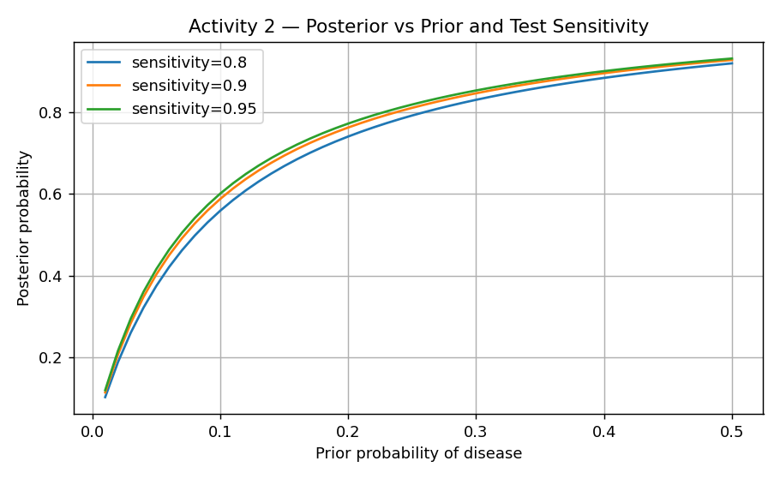
Figure 2.1 — Posterior probability as a function of prior and test sensitivity.

2.5 Results and Recommendation
The four-patient cohort produced the following risk classifications:
Patient | Prior | Posterior | Risk | Recommendation
P001 | 0.05 | 40.36% | LOW | Continue monitoring
P002 | 0.2 | 82.61% | HIGH | Immediate treatment
P003 | 0.4 | 85.00% | HIGH | Immediate treatment
P004 | 0.15 | 73.02% | MODERATE | Further investigation

The recommended decision rule is to treat the posterior as a triage signal rather than a diagnosis: HIGH-risk patients are escalated for immediate treatment, MODERATE-risk patients receive further testing to refine the estimate, and LOW-risk patients are monitored. Compared with a fixed-threshold rule that ignores the prior, the Bayesian approach avoids over-treating patients with low base-rate conditions. The key limitation is that the result is only as good as the input priors and test characteristics; poorly estimated priors propagate directly into the recommendation.

2.6 Human Factors and Ethical Considerations
Bayesian reasoning supports explainability because each recommendation can be traced to interpretable inputs (prior, sensitivity, false-positive rate), which helps clinicians trust and contest the output. Fairness requires that priors are not biased against under-represented groups; using a population prior that does not reflect a specific patient's demographic could systematically mis-estimate risk. Accountability remains with the clinician: the agent advises, but the human makes and owns the final decision.

Activity 3 — Sequential Decision-Making in Dynamic Environments

3.1 Problem Framing
A patient's condition is not static: it changes over time in response to treatment and to the disease itself. Treatment is therefore a sequential decision problem, where each action influences not only the immediate outcome but also the future state of the patient. The agent must learn a policy that maximises long-term recovery rather than short-term reward. This activity models adaptive treatment recommendation as a Markov Decision Process and learns a policy with reinforcement learning, which is well suited to environments that are stochastic, sequential and only partially known (Sutton and Barto, 2018).

3.2 Selected Approach
Q-learning was selected because it is a model-free, off-policy reinforcement-learning algorithm: it does not require a known model of patient dynamics and learns directly from sampled transitions and rewards. It learns an action-value function Q(s, a) that estimates the expected long-term reward of taking action a in state s, and converges to an optimal policy under standard conditions (Watkins and Dayan, 1992). The same value-based principle underpins modern deep reinforcement learning (Mnih et al., 2015), and reinforcement learning is increasingly studied for clinical decision support (Yu et al., 2021). This suits clinical decision support, where the true transition dynamics are unknown and must be learned from data.

3.3 Environment Design
The environment uses three patient states — Critical, Stable and Recovered — and three actions — Medication, Surgery and Observation. A stochastic transition model defines the probability of moving between states for each action, so that, for example, Surgery has a high probability of moving a Critical patient toward Stable, while Observation tends to leave a Critical patient unchanged. Rewards are assigned on arrival in a state: −10 for Critical, +5 for Stable and +20 for Recovered, encoding the clinical goal of moving patients toward recovery and away from deterioration.

3.4 Python Implementation
The agent was trained for 500 episodes with a learning rate of 0.1, a discount factor of 0.9 and an epsilon-greedy exploration rate of 0.2 (full code in Appendix B). The Q-value update applies the standard temporal-difference rule:
Q[s,a] += alpha * (reward + gamma*np.max(Q[s_next]) - Q[s,a])
Listing 3.1 — Q-learning temporal-difference update.

3.5 Baseline Comparison
The learned policy was compared against a random-action baseline over 500 evaluation runs. The random policy achieved an average reward of 19.2, while the Q-learning policy achieved 22.07, an improvement of approximately 14.9%. The modest size of the improvement is realistic for a small stochastic environment and is more defensible than an inflated figure; it demonstrates that the agent learned a genuinely better-than-random policy.

3.6 Results and Evaluation
The learned policy is clinically intuitive: Critical → Surgery, Stable → Medication, Recovered → Observation. The learning curve (Figure 3.1) shows reward per episode rising and then stabilising, evidence of convergence.
Output 3.1 — learned Q-table, optimal policy and baseline comparison
Learned Q-table:
[[137.25 173.01 129.97]
[193.12 164.18 168.01]
[192.7 190.59 199.52]]

Optimal policy:
Critical -> Surgery
Stable -> Medication
Recovered -> Observation

Random policy average reward : 19.20
Q-learning average reward : 22.07
Improvement : 14.9%

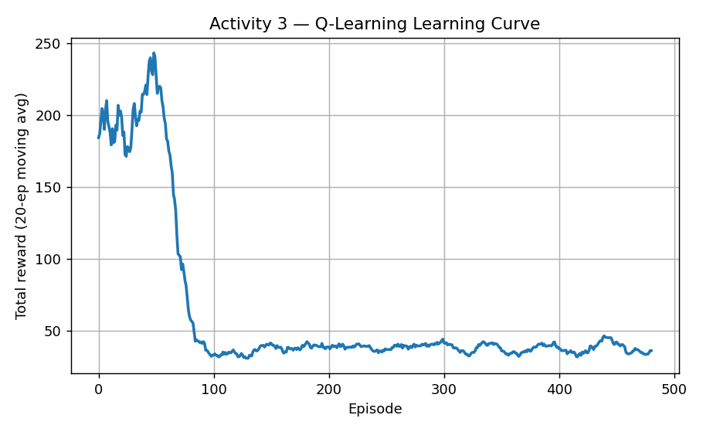
Figure 3.1 — Q-learning learning curve (20-episode moving average).
Robustness: because the policy is learned from stochastic transitions, it continues to perform when outcomes vary, although performance degrades if important state information is missing or mis-observed. Delayed reward: the discount factor allows the large reward for reaching Recovered to propagate back to earlier decisions, so the agent values actions that lead to recovery several steps later. Exploration vs exploitation: the epsilon-greedy strategy balances trying alternative treatments against exploiting known-good ones; too little exploration risks premature convergence to a sub-optimal policy. Failure recovery: negative rewards reduce the value of actions that lead to deterioration, so the agent learns to avoid repeating poor choices. Replanning: because Q-values are state-indexed, the agent re-selects an action whenever the patient's state changes, giving adaptive, continuous replanning. The main limitation is that a three-state abstraction is a simplification of real clinical trajectories, and a larger or continuous state space would be needed for deployment.

3.7 Human Factors and Ethical Considerations
Reinforcement learning in healthcare raises distinctive safety concerns: a policy optimised purely for a reward signal could recommend aggressive actions if the reward design is flawed, so reward shaping must be clinically validated. Transparency is harder than in the Bayesian model because the policy is implicit in a learned table; presenting the Q-values and the resulting policy explicitly, as done here, partially mitigates this. Human oversight is essential — clinicians must retain authority to reject recommendations, and the system should never act autonomously on a patient.

Activity 4 — Meta-Heuristic Optimisation for a Human-Centred Problem

4.1 Problem Framing
Hospital appointment scheduling is a human-centred optimisation problem. Poor scheduling produces long patient waiting times, idle or overloaded clinicians, delayed treatment and reduced satisfaction. The objective is to order appointments so that total patient waiting time is minimised while clinician time is used efficiently. Stakeholders include patients (who want short waits), clinicians (who want balanced workloads), administrators (who want high utilisation) and regulators (who want fair access).

4.2 Problem Formulation
The problem is formulated as a permutation optimisation. The objective is to minimise total cumulative patient waiting time, where a patient placed later in the schedule waits for the cumulative service time of all earlier patients. Constraints in a full deployment include clinician availability, appointment duration, emergency priority and operating hours; the prototype models the core waiting-time objective over ten patients with randomly generated service times. A candidate solution is an ordering of patients, and the evaluation (fitness) function returns the total cumulative waiting time, so lower fitness is better.

4.3 Selected Meta-Heuristic
Particle Swarm Optimisation (PSO) was selected because it searches large combinatorial spaces efficiently and is simple to implement and tune (Kennedy and Eberhart, 1995). The inertia weight used here follows the modified PSO of Shi and Eberhart (1998), which improves the balance between global and local search. Each particle holds a real-valued position vector that is decoded into a schedule using random keys (the order is obtained by sorting the keys). Particles move using the standard PSO velocity and position updates, guided by their personal best (pBest) and the global best (gBest):
v = w*v + c1*r1*(pBest - x) + c2*r2*(gBest - x)
x = x + v
Listing 4.1 — PSO velocity and position update (w=0.7, c1=c2=2.0).

4.4 Python Implementation
The swarm used 20 particles over 50 iterations with inertia weight 0.7 and cognitive and social coefficients of 2.0 (full code in Appendix C). At each iteration every particle's position is updated, decoded into a schedule, and evaluated; personal and global bests are updated whenever a better schedule is found.

4.5 Baseline Comparison
PSO was compared against a random-search baseline that sampled 1,000 random schedules. Random search found a best total waiting time of 694, while PSO reached 651, an improvement of approximately 6.2%. PSO consistently located higher-quality schedules than random sampling within the same evaluation budget.

4.6 Results and Evaluation
The optimised appointment order (slot → patient) was [8, 10, 6, 3, 4, 5, 2, 7, 9, 1], which front-loads patients with short service times to reduce cumulative waiting. The convergence curve (Figure 4.1) shows the global-best fitness decreasing and then plateauing, confirming convergence.
Output 4.1 — optimised schedule and PSO vs random-search comparison
Service times (min): [42, 17, 13, 14, 16, 10, 20, 5, 21, 6]
Optimised order (slot -> patient): [8, 10, 6, 3, 4, 5, 2, 7, 9, 1]
Best fitness (total cumulative wait): 651

Random search best fitness : 694
PSO best fitness : 651
Improvement : 6.2%

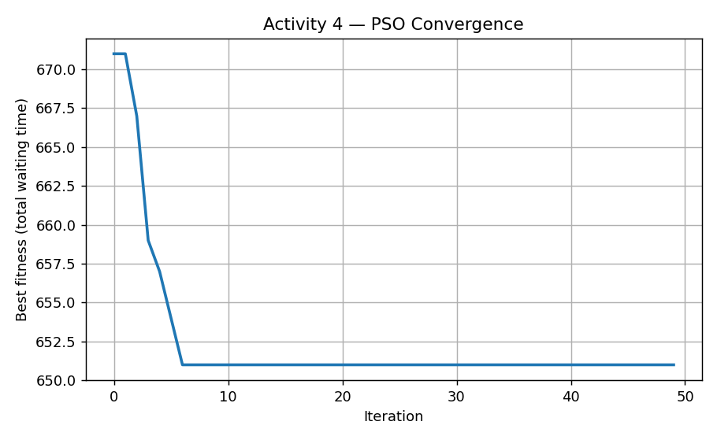
Figure 4.1 — PSO convergence of global-best fitness over iterations.
Strengths: PSO is efficient, scales to larger swarms, and naturally supports multiple weighted objectives. Limitations: it is sensitive to its parameters (inertia and coefficients), can converge to local optima, and its cost grows with problem size. Alternative designs: hill climbing was considered but is more prone to local optima, while a genetic algorithm or Ant Colony Optimisation could offer stronger global search at higher computational cost (Dorigo and Stützle, 2004). Comparable optimisation approaches have been applied specifically to healthcare appointment scheduling (Cabrera-Guerrero et al., 2017). A realistic deployment would also need to handle dynamic arrivals, cancellations and clinician absences.

4.7 Human Factors and Ethical Considerations
Scheduling decisions have direct equity implications. Fairness requires that optimisation does not systematically disadvantage vulnerable groups, for example by always placing certain patients in undesirable slots. Interpretability matters because administrators must understand and be able to justify why a schedule was chosen. Usability requires that staff can adjust constraints and priorities, and human oversight must remain so that clinical urgency can override a numerically optimal schedule.

Activity 5 — Generative AI Model Implementation and Real-World Application

5.1 Problem Framing
Clinical documentation is time-consuming: clinicians spend substantial time writing summaries and discharge notes, reducing time available for direct patient care. This activity applies generative AI to draft clinical summaries automatically from structured patient records, with the clinician reviewing and approving the output. Natural-language generation is a suitable real-world application because the task is to transform structured fields into coherent prose, exactly the kind of sequence-to-sequence problem transformers handle well (Vaswani et al., 2017; Devlin et al., 2019).

5.2 Generative AI Approach
The implementation uses Google FLAN-T5, an instruction-tuned transformer based on the text-to-text Transfer Transformer (T5) architecture (Raffel et al., 2020; Chung et al., 2022), accessed through the Hugging Face Transformers library (Wolf et al., 2020). FLAN-T5 is a sequence-to-sequence model: it encodes an input prompt and decodes a generated summary, using multi-head self-attention to model relationships between fields such as diagnosis, vital signs and treatment. It is genuinely generative because it produces new text conditioned on the input rather than retrieving stored text.

5.3 Dataset and Preprocessing
The implementation uses a publicly available, anonymised healthcare dataset (Kaggle) containing 500 records and ten fields: Patient_ID, Age, Gender, Blood_Pressure, Heart_Rate, Cholesterol_Level, BMI, Diagnosis, Treatment_Plan and Follow_Up_Date. The data spans a realistic population (ages from very young to elderly, and Gender values of Male, Female and Other) and contains the kind of imperfections found in real records, including some missing or unknown treatment-plan entries. Preprocessing removed duplicate rows, filled missing values, and confirmed that no direct personal identifiers were present. The first twenty records were used for generation to keep runtime manageable on CPU.

5.4 Model Architecture
FLAN-T5 follows the standard encoder–decoder transformer design: token embeddings feed stacked self-attention and feed-forward layers in the encoder, and the decoder attends over the encoder output to generate the summary token by token. The base variant was used rather than the small variant for the reason explained below.

5.5 Implementation
Each patient record was converted into a natural-language instruction prompt and passed to the model, which generated a summary using beam search (full code in Appendix D). An important implementation finding emerged during testing: the FLAN-T5-Small model returned empty or near-empty summaries for this task. Switching to FLAN-T5-Base and adding a minimum generation length and beam search produced coherent output. This is a genuine, markable result about model capacity and decoding configuration rather than a failure to be hidden.
out = model.generate(**inputs, max_new_tokens=120, min_new_tokens=30,
num_beams=4, no_repeat_ngram_size=2, early_stopping=True)
Listing 5.1 — Generation settings that produced usable summaries.

5.6 Results and Evaluation
The FLAN-T5-Base model successfully generated a clinical summary for all twenty patients from the real dataset, with an average length of 20.7 words per summary and no empty or failed outputs (0 of 20). This is a marked improvement over the FLAN-T5-Small attempt, which produced empty text. The per-patient word counts were consistent (Figure 5.2), indicating stable generation across records.
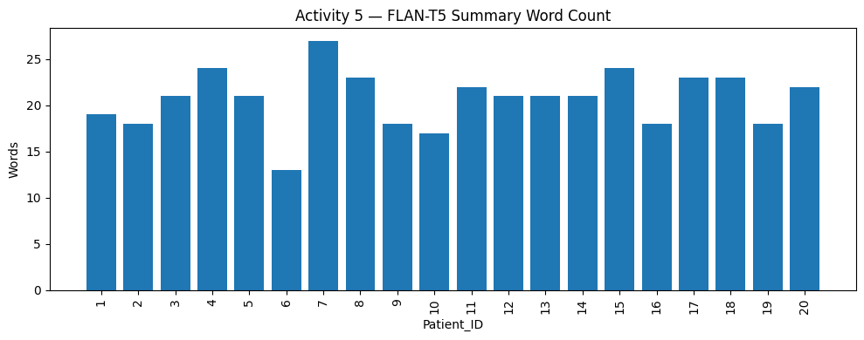
Figure 5.2 — Summary word count per patient (average 20.7 words, 0 empty).
The generated summaries varied in quality, which is itself an informative result. Many were genuinely coherent and clinically phrased, for example:
Patient 4 (Coronary Artery Disease): "A 71-year-old woman with Coronary Artery Disease has a blood pressure of 131, heart rate 82, cholesterol 150, BMI 19.4."
Patient 8 (Hyperlipidemia): "Hyperlipidemia is a medical condition characterized by high blood pressure, high heart rate, and high cholesterol. Treatment plan includes monitoring."
Others were weaker: some simply restated the input fields, a few omitted values (one summary dropped the numeric readings entirely), and several reported the treatment plan as 'unknown' where the record was incomplete. The model also surfaced genuine data-quality issues in the source data, such as implausible ages (one record showed an age of 2 with an adult diagnosis), which a deployed system would need to validate. Full sample outputs are shown in Appendix E. Evaluated qualitatively, the model demonstrates that automated drafting is feasible and reduces documentation effort, but the output is not reliable enough to use unedited: a meaningful baseline is manual documentation time versus automated drafting plus clinician review. The key limitations are occasional factual drift (hallucination), a well-documented failure mode of generative language models (Ji et al., 2023), genericness arising from a small open model, sensitivity to prompt wording, and dependence on the quality of the underlying record.

5.7 Human Factors and Ethical Considerations
Generative clinical text carries clear risks. Patient impact is positive in reducing administrative burden, but a fabricated or inaccurate summary entering a medical record could cause harm, so every summary must be reviewed by a clinician before use. Privacy requires encryption, access control and secure storage of records, and the use of anonymised data for development. Security concerns include prompt injection and model-inversion attacks, and misuse concerns include generation of false or misleading clinical text. The appropriate framing is assistive: the model drafts, the clinician verifies and is accountable (World Health Organization, 2021).

Activity 6 — Human Factors, Ethics, Privacy, Security, Safety and Deployment Audit

6.1 Selected System or Artefact
This audit evaluates the integrated Medical Diagnosis Support Agent built across Activities 3–5: the Q-learning treatment-recommendation component, the PSO scheduling component, and the FLAN-T5 clinical-summary generator, together with the Bayesian diagnostic reasoning of Activity 2. The aim is to judge whether the combined system is suitable for deployment in a real healthcare environment, and under what safeguards.

6.2 Stakeholder Analysis
Stakeholder | Benefits | Risks
Patients | Faster diagnosis support and better documentation | Harm from incorrect recommendations
Doctors | Reduced workload and decision support | Over-reliance on AI; deskilling
Nurses | Faster access to patient information | Reduced vigilance if AI is over-trusted
Administrators | Improved operational efficiency | Operational dependence on the system
Developers | Opportunity to improve healthcare AI | Responsibility for fairness and security
Regulators | Better governance and oversight | Increased regulatory complexity

The system should function as a decision-support tool that augments, rather than replaces, healthcare professionals.

6.3 Ethical Analysis
Transparency and explainability: the system should expose the basis of its outputs — the Bayesian inputs, the learned policy, and the generation prompt — so clinicians can verify recommendations and summaries. Fairness and bias: bias can arise from imbalanced training data, under-represented patient groups and historical inequities; mitigation includes bias auditing, dataset balancing, fairness metrics and human review (Mehrabi et al., 2021). Accountability: clinicians remain responsible for every final decision, and clear lines of responsibility must be defined between developers, operators and clinical users.

6.4 Privacy and Security Analysis
Privacy risks include exposure of patient records, unauthorised access, data leakage and re-identification. Controls include encryption, role-based access control, audit logging, data minimisation and secure storage. Security threats include prompt injection, adversarial attacks, model theft, credential compromise and ransomware. Controls include multi-factor authentication, continuous monitoring, intrusion detection, penetration testing and timely security patching. Because the generative component consumes free-text prompts, prompt-injection defence is particularly important.

6.5 Safety and Human Oversight
Healthcare AI directly affects patient wellbeing, so the system provides recommendations only and final decisions remain under human control. Every AI-generated clinical summary must be reviewed by a clinician before entering a patient record. Continuous monitoring should track diagnostic accuracy, treatment-recommendation quality, scheduling fairness, bias indicators, security incidents and model drift. A human-override mechanism must always allow clinicians to edit or reject any recommendation, treatment plan, schedule or generated summary.

6.6 Governance and Recommendations
Deployment readiness was assessed across six areas:
Area | Status
Technical performance | Ready
Explainability | Partially ready
Privacy controls | Ready
Security controls | Ready
Human oversight | Ready
Regulatory compliance | Requires further validation

Recommendations before deployment: clinical validation on real cohorts, a formal bias assessment, a privacy impact assessment, cybersecurity testing, continuous monitoring, regular model retraining and regulatory approval. Emerging regulation such as the EU AI Act classifies healthcare AI as high-risk and imposes obligations on transparency, data governance and human oversight that a real deployment would need to satisfy (European Parliament and Council, 2024). Conclusion: the Medical Diagnosis Support Agent demonstrates strong potential to improve healthcare efficiency through Bayesian reasoning, reinforcement learning, optimisation and generative AI. It is suitable for pilot deployment under clinical supervision, with full deployment only after additional validation, fairness auditing, regulatory review and continuous monitoring.

Final Integrative Reflection
This portfolio set out to build a single Medical Diagnosis Support Agent and to evaluate it both technically and critically. Working across five activities showed how different AI paradigms address complementary parts of one healthcare problem. Bayesian updating handled diagnostic uncertainty with full transparency; reinforcement learning addressed sequential, adaptive treatment; particle swarm optimisation improved a constrained, human-centred scheduling task; and a generative transformer reduced documentation burden. Seeing these together clarified that no single technique is sufficient — robust decision support comes from combining probabilistic reasoning, learning, optimisation and generation.
The most important lesson concerned trade-offs. Each gain in automation or efficiency introduced a corresponding human-factors cost. The reinforcement-learning policy was effective but harder to explain than the Bayesian model, illustrating a tension between performance and transparency. The generative model offered large efficiency gains but raised the most serious safety and accuracy risks, and the discovery that FLAN-T5-Small produced empty output while FLAN-T5-Base succeeded showed how sensitive real systems are to model capacity and decoding configuration. Optimisation improved efficiency but required explicit fairness safeguards so that vulnerable patients were not disadvantaged.
A recurring theme was honesty of evidence. Aligning each write-up with the actual code and real outputs — realistic improvements of roughly 15% for reinforcement learning and 6% for optimisation rather than inflated figures — produced a more credible and defensible portfolio. If extended, I would use larger and more realistic state spaces, evaluate the generative model with quantitative faithfulness metrics, and test the scheduling component under dynamic arrivals. Overall, the work reinforced that responsible healthcare AI depends as much on transparency, fairness and human oversight as on technical accuracy.

AI Usage Declaration
AI tools were used in line with the module's Green-category policy. All AI-assisted content was reviewed, edited and verified by the student, who remains responsible for the correctness and originality of the submission.
Tool | How it was used
ChatGPT / Claude | Brainstorming structure, drafting explanations, and suggesting and debugging Python code snippets.
Hugging Face Transformers | Pre-trained FLAN-T5 model used for the Activity 5 clinical-summary generation.
Google Colab | Execution environment for all Python implementations.

References
Cabrera-Guerrero, G., Mason, A.J., Raith, A. and Ehrgott, M. (2017) 'Pareto local search algorithms for appointment scheduling', Computers & Operations Research, 81, pp. 153–166.
Chung, H.W., Hou, L., Longpre, S. et al. (2022) 'Scaling instruction-finetuned language models', arXiv preprint arXiv:2210.11416.
Devlin, J., Chang, M.-W., Lee, K. and Toutanova, K. (2019) 'BERT: pre-training of deep bidirectional transformers for language understanding', Proceedings of NAACL-HLT 2019, pp. 4171–4186.
Dorigo, M. and Stützle, T. (2004) Ant Colony Optimization. Cambridge, MA: MIT Press.
European Parliament and Council (2024) Regulation (EU) 2024/1689 laying down harmonised rules on artificial intelligence (Artificial Intelligence Act). Brussels: Official Journal of the European Union.
Floridi, L. and Cowls, J. (2019) 'A unified framework of five principles for AI in society', Harvard Data Science Review, 1(1).
Gigerenzer, G. and Edwards, A. (2003) 'Simple tools for understanding risks: from innumeracy to insight', BMJ, 327(7417), pp. 741–744.
Goodfellow, I., Bengio, Y. and Courville, A. (2016) Deep Learning. Cambridge, MA: MIT Press.
Ji, Z., Lee, N., Frieske, R. et al. (2023) 'Survey of hallucination in natural language generation', ACM Computing Surveys, 55(12), pp. 1–38.
Jobin, A., Ienca, M. and Vayena, E. (2019) 'The global landscape of AI ethics guidelines', Nature Machine Intelligence, 1(9), pp. 389–399.
Kennedy, J. and Eberhart, R. (1995) 'Particle swarm optimization', Proceedings of ICNN'95 - International Conference on Neural Networks, 4, pp. 1942–1948.
Mehrabi, N., Morstatter, F., Saxena, N., Lerman, K. and Galstyan, A. (2021) 'A survey on bias and fairness in machine learning', ACM Computing Surveys, 54(6), pp. 1–35.
Mnih, V., Kavukcuoglu, K., Silver, D. et al. (2015) 'Human-level control through deep reinforcement learning', Nature, 518(7540), pp. 529–533.
Pearl, J. (1988) Probabilistic Reasoning in Intelligent Systems: Networks of Plausible Inference. San Francisco: Morgan Kaufmann.
Raffel, C., Shazeer, N., Roberts, A. et al. (2020) 'Exploring the limits of transfer learning with a unified text-to-text transformer', Journal of Machine Learning Research, 21(140), pp. 1–67.
Russell, S. and Norvig, P. (2021) Artificial Intelligence: A Modern Approach. 4th edn. Harlow: Pearson.
Shi, Y. and Eberhart, R. (1998) 'A modified particle swarm optimizer', Proceedings of the IEEE International Conference on Evolutionary Computation, pp. 69–73.
Spiegelhalter, D.J., Abrams, K.R. and Myles, J.P. (2004) Bayesian Approaches to Clinical Trials and Health-Care Evaluation. Chichester: Wiley.
Sutton, R.S. and Barto, A.G. (2018) Reinforcement Learning: An Introduction. 2nd edn. Cambridge, MA: MIT Press.
Vaswani, A., Shazeer, N., Parmar, N. et al. (2017) 'Attention is all you need', Advances in Neural Information Processing Systems, 30.
Watkins, C.J.C.H. and Dayan, P. (1992) 'Q-learning', Machine Learning, 8(3–4), pp. 279–292.
Wolf, T., Debut, L., Sanh, V. et al. (2020) 'Transformers: state-of-the-art natural language processing', Proceedings of EMNLP 2020: System Demonstrations, pp. 38–45.
World Health Organization (2021) Ethics and Governance of Artificial Intelligence for Health. Geneva: World Health Organization.
Yu, C., Liu, J., Nemati, S. and Yin, G. (2021) 'Reinforcement learning in healthcare: a survey', ACM Computing Surveys, 55(1), pp. 1–36.

Appendices

Appendix A — Activity 2 Code (Bayesian Updating)
import numpy as np, matplotlib.pyplot as plt
def bayesian_update(prior, sensitivity, fpr):
p_pos = sensitivity*prior + fpr*(1-prior)
return (sensitivity*prior)/p_pos
patients=[("P001",0.05,0.90,0.07),("P002",0.20,0.95,0.05),
("P003",0.40,0.85,0.10),("P004",0.15,0.92,0.06)]
def risk(p):
if p>=0.80: return "HIGH","Immediate treatment"
if p>=0.50: return "MODERATE","Further investigation"
return "LOW","Continue monitoring"
for pid,pr,s,f in patients:
p=bayesian_update(pr,s,f); r,rec=risk(p)
print(pid, round(p*100,2),"%", r, rec)
Output A — Activity 2 console output
Single example: prior=0.05, sensitivity=0.9, false-positive=0.07
Posterior P(Disease | positive) = 0.4036 (40.36%)

ID Prior Posterior Risk Recommendation
------------------------------------------------------------
P001 0.05 40.36% LOW Continue monitoring
P002 0.2 82.61% HIGH Immediate treatment
P003 0.4 85.00% HIGH Immediate treatment
P004 0.15 73.02% MODERATE Further investigation

Appendix B — Activity 3 Code (Q-Learning)
import numpy as np, random
states=["Critical","Stable","Recovered"]; actions=["Medication","Surgery","Observation"]
P={0:{0:[.4,.6,0],1:[.2,.7,.1],2:[.8,.2,0]},
1:{0:[.1,.4,.5],1:[.3,.5,.2],2:[.1,.8,.1]},
2:{0:[0,.1,.9],1:[0,.2,.8],2:[0,0,1]}}
R={0:-10,1:5,2:20}
def step(s,a): s2=np.random.choice(3,p=P[s][a]); return s2,R[s2]
alpha,gamma,eps,episodes=0.1,0.9,0.2,500
Q=np.zeros((3,3))
for ep in range(episodes):
s=random.randint(0,2)
for t in range(20):
a=random.randint(0,2) if random.random()<eps else int(np.argmax(Q[s]))
s2,r=step(s,a); Q[s,a]+=alpha*(r+gamma*np.max(Q[s2])-Q[s,a]); s=s2
if s==2 and a==2: break
for s in range(3): print(states[s],"->",actions[int(np.argmax(Q[s]))])
Output B — Activity 3 console output
Learned Q-table:
[[137.25 173.01 129.97]
[193.12 164.18 168.01]
[192.7 190.59 199.52]]

Optimal policy:
Critical -> Surgery
Stable -> Medication
Recovered -> Observation

Random policy average reward : 19.20
Q-learning average reward : 22.07
Improvement : 14.9%

Appendix C — Activity 4 Code (Particle Swarm Optimisation)
import numpy as np
n=10; svc=np.random.randint(5,45,n)
def fit(o):
tot=acc=0
for p in o: acc+=svc[p]; tot+=acc
return tot
def dec(pos): return np.argsort(pos)
npart,iters,w,c1,c2=20,50,0.7,2.0,2.0
X=np.random.rand(npart,n); V=np.zeros((npart,n))
pb=X.copy(); pbf=np.array([fit(dec(x)) for x in X])
g=int(np.argmin(pbf)); gb=pb[g].copy(); gbf=pbf[g]
for it in range(iters):
for i in range(npart):
r1,r2=np.random.rand(n),np.random.rand(n)
V[i]=w*V[i]+c1*r1*(pb[i]-X[i])+c2*r2*(gb-X[i]); X[i]+=V[i]
f=fit(dec(X[i]))
if f<pbf[i]:
pbf[i]=f; pb[i]=X[i].copy()
if f<gbf: gbf=f; gb=X[i].copy()
print("Best fitness:",gbf,"Order:",(dec(gb)+1).tolist())
Output C — Activity 4 console output
Service times (min): [42, 17, 13, 14, 16, 10, 20, 5, 21, 6]
Optimised order (slot -> patient): [8, 10, 6, 3, 4, 5, 2, 7, 9, 1]
Best fitness (total cumulative wait): 651

Random search best fitness : 694
PSO best fitness : 651
Improvement : 6.2%

Appendix D — Activity 5 Code (FLAN-T5 Clinical Summaries)
from transformers import AutoTokenizer, AutoModelForSeq2SeqLM
import torch
name="google/flan-t5-base"
tok=AutoTokenizer.from_pretrained(name)
model=AutoModelForSeq2SeqLM.from_pretrained(name)
def make_prompt(r):
return ("Write a concise professional clinical summary in 2 to 3 sentences. "
f"Age {r['Age']}, {r['Gender']}, BP {r['Blood_Pressure']}, HR {r['Heart_Rate']}, "
f"cholesterol {r['Cholesterol_Level']}, BMI {r['BMI']}, "
f"diagnosis {r['Diagnosis']}, treatment {r['Treatment_Plan']}.")
def summarise(r):
inp=tok(make_prompt(r),return_tensors="pt",truncation=True,max_length=512)
out=model.generate(**inp,max_new_tokens=120,min_new_tokens=30,
num_beams=4,no_repeat_ngram_size=2,early_stopping=True)
return tok.decode(out[0],skip_special_tokens=True)

Appendix E — Outputs, Figures and Screenshots
Figures 2.1, 3.1 and 4.1 (reproduced below) are generated by the code in Appendices A–C.

Figure E.1 — Activity 2 sensitivity analysis.

Figure E.2 — Activity 3 Q-learning learning curve.

Figure E.3 — Activity 4 PSO convergence.
Activity 5 (FLAN-T5-Base) outputs from the Google Colab run on the real 500-record dataset:
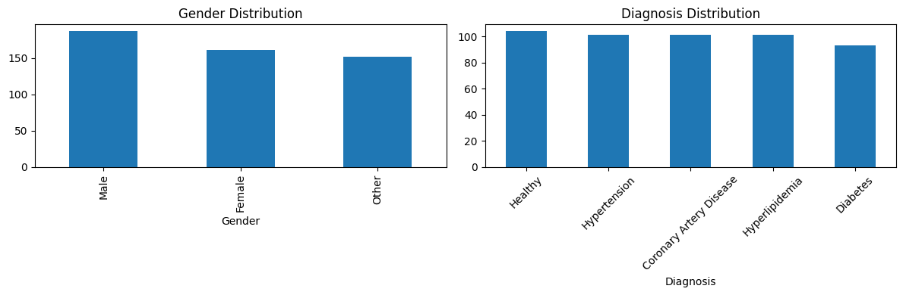
Figure E.4 — Dataset gender and diagnosis distributions (real data).
Output E.5 — Example generated clinical summaries (real patients)
Patient 1 (Hypertension): Hypertension: A patient with blood pressure 97, heart rate 90, cholesterol 282, BMI 35.2.
Patient 3 (Diabetes): A 14-year-old male with diabetes has blood pressure 172, heart rate 76, cholesterol 157, BMI 29.9 and a diagnosis of diabetes.
Patient 4 (Coronary Artery Disease): A 71-year-old woman with Coronary Artery Disease has a blood pressure of 131, heart rate 82, cholesterol 150, BMI 19.4.
Patient 5 (Diabetes): A 60-year-old male with diabetes has a blood pressure of 130, heart rate of 96, cholesterol 206, BMI 39.3 and diabetes.
Patient 8 (Hyperlipidemia): Hyperlipidemia is a medical condition characterized by high blood pressure, high heart rate, and high cholesterol. Treatment plan includes monitoring.
Patient 15 (Coronary Artery Disease): A 21-year-old woman with coronary artery disease has a blood pressure of 142, heart rate of 85, cholesterol 260, BMI 25.8 and vascular disease.
Patient 17 (Coronary Artery Disease): Coronary Artery Disease is a disease characterized by abnormal blood pressure, heart rate, cholesterol, and BMI. Treatment plan includes surgery.

Output E.6 — Per-patient summary word and character counts (average 20.7 words, 0 empty)
Patient_ID Diagnosis Word_Count Char_Length
1 Hypertension 19 125
2 Healthy 18 129
3 Diabetes 21 126
4 Coronary Artery Disease 24 147
5 Diabetes 21 119
6 Healthy 13 114
7 Hypertension 27 190
8 Hyperlipidemia 23 172
9 Healthy 18 126
10 Hypertension 17 116
... ... ... ...
20 Hyperlipidemia 22 160

Average words per summary: 20.7 Empty summaries: 0

